Project Report

Introduction
This project is a 2D computer graphics simulation of a moving steam train, developed to demonstrate fundamental animation, user interaction, and shape rendering techniques. Set against a vibrant landscape with a dynamic sky gradient, the simulation features a train that continuously traverses the screen with physically synchronized wheel rotation and a dynamic smoke particle system. The core uniqueness of this project lies in its strict rendering constraints: every element on the screen—from solid circles and rectangles to complex shapes like the cowcatcher—is constructed entirely from fundamental 1D line segments, showcasing the power of basic mathematics in computer graphics.

Problem Statement
What problem exists:
Modern graphics development often relies heavily on high-level libraries, pre-built polygon functions, or external game engines to render solid shapes and handle physics. Relying solely on these tools can abstract away the underlying mathematics of rendering, leaving students and developers with a gap in understanding how primitive shapes are mathematically constructed, filled, and animated at the lowest level.

What your project addresses:
This project addresses this gap by imposing a strict constraint: constructing an entire animated, interactive scene using only basic line primitives (GL_LINES) and integer-based vertices (glVertex2i). It demonstrates how to manually implement algorithms for solid shape filling (like horizontal line scanning for circles and rectangles), linear interpolation for gradients, and basic physics calculations for particle systems, effectively building a complex scene from fundamental graphical building blocks.

4. Objectives
- Simulate Realistic Movement: To create a smooth, continuous 2D animation of a train moving across the screen with mathematically synchronized wheel rotation.
- Develop a Particle System: To implement a dynamic, alpha-blended smoke effect that simulates physics (rising, expanding, and fading over time).
- Understand Primitive Constraints: To construct all solid and hollow visual elements (circles, polygons, gradients) strictly using the fundamental GL_LINES primitive.
- Implement User Interaction: To allow real-time control over the simulation environment via keyboard inputs, specifically allowing the user to dynamically increase or decrease the train's speed.
- Optimize Performance: To maintain an efficient, double-buffered animation loop running at a steady frame rate (~60 FPS) without memory leaks.

5. Algorithms Used
To construct the scene under the strict GL_LINES constraint, several mathematical algorithms and concepts were utilized:
- Circle Rasterization (Horizontal Line Scanning): To draw filled circles without polygons, the Pythagorean theorem is utilized. By iterating through the y-axis, the algorithm calculates the corresponding x-axis offset to draw horizontal lines between the two calculated boundaries.
- Trigonometric Rotation: Wheel spokes and circular outlines are calculated using standard sine and cosine functions. The endpoints of the lines are updated continuously based on a rotating angle variable that scales proportionally with the train's movement speed.
- Linear Interpolation (Lerp): The sky background is drawn using horizontal lines where the RGB color values are linearly interpolated based on the vertical position (y-coordinate) to create a smooth, seamless gradient transition from dark blue to light blue.
- Particle System Physics: The smoke animation relies on a continuous update loop where each particle's variables (x and y velocity, radius, and alpha transparency) are modified mathematically per frame. A randomization algorithm is applied to the spawn position and drift to create an organic, non-uniform smoke plume.

6. Implementation
Programming Language Used:
- C++: Chosen for its speed, efficiency, and robust standard library. The standard template library (STL), specifically std::vector, is used to dynamically manage the memory of the smoke particle system, allowing particles to be created and destroyed efficiently as they fade out.
Graphics Libraries/Tools:
- OpenGL (Open Graphics Library): The core API used for rendering 2D vector graphics. Specifically, the project heavily relies on the GL_LINES primitive, GL_BLEND for transparency, and matrix transformations for component-based animation.
- GLUT (OpenGL Utility Toolkit): Used for window system independence. GLUT handles the creation of the 800x600 display window, capturing keyboard events for user interaction, and managing the timer-based animation loop. Double buffering (GLUT_DOUBLE) is implemented to completely eliminate visual flickering.
Code:
- #include <GL/glut.h>
- #include <bits/stdc++.h>
- using namespace std;

- float trainX = -500.0f; // train horizontal position
- float wheelAngle = 0.0f; // wheel rotation angle (degrees)
- float trainSpeed = 1.5f; // train movement speed
- struct SmokeParticle {
- float x, y, alpha, size, speed;
- };
- // Solid filled circle using horizontal line scanning
- vector<SmokeParticle> smoke;
- void drawCircle(int cx, int cy, int r) {
- glBegin(GL_LINES);
- for (int dy = -r; dy <= r; ++dy) {
- int dx = round(sqrt(r * r - dy * dy));
- glVertex2i(cx - dx, cy + dy);
- glVertex2i(cx + dx, cy + dy);
- }
- glEnd();
- }
- // Hollow circle outline using GL_LINES segments
- void drawCircleOutline(int cx, int cy, int r, int segs = 64) {
- glBegin(GL_LINES);
- int prevX = cx + r;
- int prevY = cy;
- for (int i = 1; i <= segs; ++i) {
- float a = 2.0f * M_PI * i / segs;
- int x = cx + round(r * cos(a));
- int y = cy + round(r * sin(a));
- glVertex2i(prevX, prevY);
- glVertex2i(x, y);
- prevX = x; prevY = y;
- }
- glEnd();
- }
- // Solid filled rectangle using horizontal line scanning
- void drawRect(int x, int y, int w, int h) {
- glBegin(GL_LINES);
- for (int i = 0; i < h; ++i) {
- glVertex2i(x, y + i);
- glVertex2i(x + w, y + i);
- }
- glEnd();
- }
- // Sky gradient filled with horizontal GL_LINES
- void drawSky() {
- glBegin(GL_LINES);
- for (int y = 200; y <= 600; ++y) {
- float t = (float)(y - 200) / 400.0f;
- // Interpolate from bottom color to top color
- float r = 0.87f + t * (0.53f - 0.87f);
- float g = 0.95f + t * (0.81f - 0.95f);
- float b = 1.00f + t * (0.98f - 1.00f);
- glColor3f(r, g, b);
- glVertex2i(0, y);
- glVertex2i(800, y);
- }
- glEnd();
- }
- // Ground
- void drawGround() {
- glColor3f(0.42f, 0.56f, 0.26f);
- drawRect(0, 0, 800, 215);
- glColor3f(0.48f, 0.65f, 0.30f);
- drawRect(0, 210, 800, 12);
- }
- // Railway tracks
- void drawTracks() {
- glColor3f(0.35f, 0.22f, 0.08f);
- for (int x = 0; x <= 800; x += 40) {
- drawRect(x, 192, 26, 10);
- }
- glColor3f(0.60f, 0.60f, 0.65f);
- drawRect(0, 200, 800, 6);
- drawRect(0, 187, 800, 6);
- glColor3f(0.85f, 0.85f, 0.90f);
- drawRect(0, 203, 800, 2);
- drawRect(0, 190, 800, 2);
- }
- // Wheel
- void drawWheel(int cx, int cy, int r) {
- glColor3f(0.15f, 0.15f, 0.15f);
- drawCircle(cx, cy, r);
- glColor3f(0.80f, 0.30f, 0.10f);
- drawCircle(cx, cy, round(r * 0.55f));
- glColor3f(0.90f, 0.50f, 0.20f);
- glLineWidth(2.5f);
- glPushMatrix();
- glTranslatef(cx, cy, 0);
- glRotatef(wheelAngle, 0, 0, 1);
- glBegin(GL_LINES);
- for (int i = 0; i < 6; ++i) {
- float a = 2.0f * M_PI * i / 6;
- glVertex2i(0, 0);
- glVertex2i(round((r - 2) * cos(a)), round((r - 2) * sin(a)));
- }
- glEnd();
- glPopMatrix();
- glColor3f(0.20f, 0.20f, 0.20f);
- drawCircle(cx, cy, round(r * 0.12f));
- glColor3f(0.30f, 0.30f, 0.30f);
- glLineWidth(1.5f);
- drawCircleOutline(cx, cy, r);
- }
- // Train
- void drawTrain(int tx) {
- int tenderX = tx - 155;
- glColor3f(0.20f, 0.20f, 0.22f);
- drawRect(tenderX, 215, 130, 55);
- glColor3f(0.15f, 0.15f, 0.17f);
- drawRect(tenderX + 5, 260, 120, 12);
- glColor3f(0.12f, 0.12f, 0.12f);
- drawRect(tenderX + 10, 265, 110, 8);
- drawWheel(tenderX + 25, 205, 18);
- drawWheel(tenderX + 75, 205, 18);
- drawWheel(tenderX + 115, 205, 18);
- glColor3f(0.50f, 0.50f, 0.50f);
- drawRect(tx - 25, 220, 28, 8);
- glColor3f(0.85f, 0.20f, 0.12f);
- drawRect(tx, 220, 170, 60);
- glColor3f(0.80f, 0.18f, 0.10f);
- drawCircle(tx + 50, 283, 18);
- glColor3f(0.25f, 0.22f, 0.20f);
- drawRect(tx + 115, 230, 60, 70);
- glColor3f(0.18f, 0.15f, 0.13f);
- drawRect(tx + 110, 298, 70, 10);
- glColor3f(0.55f, 0.85f, 0.95f);
- drawRect(tx + 122, 258, 20, 22);
- drawRect(tx + 150, 258, 20, 22);

- // Window frames (Using GL_LINES)
- glColor3f(0.60f, 0.60f, 0.60f);
- glLineWidth(1.5f);
- glBegin(GL_LINES);
- glVertex2i(tx + 122, 258); glVertex2i(tx + 142, 258);
- glVertex2i(tx + 142, 258); glVertex2i(tx + 142, 280);
- glVertex2i(tx + 142, 280); glVertex2i(tx + 122, 280);
- glVertex2i(tx + 122, 280); glVertex2i(tx + 122, 258);
- glVertex2i(tx + 150, 258); glVertex2i(tx + 170, 258);
- glVertex2i(tx + 170, 258); glVertex2i(tx + 170, 280);
- glVertex2i(tx + 170, 280); glVertex2i(tx + 150, 280);
- glVertex2i(tx + 150, 280); glVertex2i(tx + 150, 258);
- glEnd();
- glColor3f(0.20f, 0.18f, 0.16f);
- drawRect(tx - 2, 222, 24, 55);
- drawCircle(tx + 10, 250, 14);
- glColor3f(0.50f, 0.50f, 0.50f);
- drawCircle(tx + 10, 250, 6);
- glColor3f(0.70f, 0.15f, 0.08f);
- for (int i = 0; i < 3; ++i)
- drawRect(tx + 30 + i * 28, 220, 5, 60);

- glColor3f(0.30f, 0.30f, 0.30f);
- drawRect(tx - 5, 217, 185, 8);
- glColor3f(0.50f, 0.50f, 0.55f);
- glBegin(GL_LINES);
- for (int y = 207; y <= 217; ++y) {
- int dx = round(30.0f * (217 - y) / 10.0f);
- glVertex2i(tx - dx, y);
- glVertex2i(tx, y);
- }
- for (int y = 207; y <= 210; ++y) {
- glVertex2i(tx - 30, y);
- glVertex2i(tx, y);
- }
- glEnd();
- glColor3f(1.0f, 0.95f, 0.60f);
- drawCircle(tx + 2, 265, 7);
- glColor3f(1.0f, 1.0f, 0.80f);
- drawCircle(tx + 2, 265, 3);
- glColor3f(0.18f, 0.15f, 0.13f);
- drawRect(tx + 15, 280, 22, 35);
- drawRect(tx + 10, 312, 32, 8);
- drawWheel(tx + 30, 205, 22);
- drawWheel(tx + 80, 205, 22);
- drawWheel(tx + 130, 205, 22);
- drawWheel(tx - 10, 207, 14);
- drawWheel(tx + 162, 207, 14);
- glColor3f(0.70f, 0.70f, 0.72f);
- glLineWidth(4.0f);
- glBegin(GL_LINES);
- glVertex2i(tx + 30, 205); glVertex2i(tx + 80, 205);
- glVertex2i(tx + 80, 205); glVertex2i(tx + 130, 205);
- glEnd();
- glColor3f(0.60f, 0.60f, 0.62f);
- drawRect(tx + 5, 212, 30, 5);
- glLineWidth(2.0f);
- glBegin(GL_LINES);
- glVertex2i(tx + 35, 214); glVertex2i(tx + 30, 205);
- glEnd();
- }
- // Smoke
- void spawnSmoke(float baseX, float baseY) {
- if (smoke.size() < 40) {
- SmokeParticle p;
- p.x = baseX + (rand() % 10 - 5);
- p.y = baseY;
- p.alpha = 0.75f + 0.25f * (rand() % 100) / 100.0f;
- p.size = 10.0f + rand() % 12;
- p.speed = 0.6f + 0.4f * (rand() % 100) / 100.0f;
- smoke.push_back(p);
- }
- }
- void drawSmoke() {
- for (auto &p : smoke) {
- glColor4f(0.55f, 0.55f, 0.55f, p.alpha);
- drawCircle(round(p.x), round(p.y), round(p.size));
- }
- }
- void updateSmoke(float stackX, float stackY) {
- for (auto &p : smoke) {
- p.y += p.speed * 1.2f;
- p.x += (rand() % 3 - 1) * 0.3f;
- p.size += 0.25f;
- p.alpha -= 0.008f;
- }
- smoke.erase(
- remove_if(smoke.begin(), smoke.end(), [](const SmokeParticle &p) { return p.alpha <= 0; }),
- smoke.end()
- );
- spawnSmoke(stackX, stackY);
- }
- // Keyboard Control
- void keyboard(unsigned char key, int x, int y) {
- if (key == 'u' || key == 'U') {
- trainSpeed += 0.5f; // Increase speed
- } else if (key == 'd' || key == 'D') {
- trainSpeed -= 0.5f; // Decrease speed
- if (trainSpeed < 0.0f) {
- trainSpeed = 0.0f; // Prevent train from going backwards
- }
- }
- }
- void display() {
- glClear(GL_COLOR_BUFFER_BIT);
- drawSky();
- drawGround();
- drawTracks();

- glEnable(GL_BLEND);
- glBlendFunc(GL_SRC_ALPHA, GL_ONE_MINUS_SRC_ALPHA);
- drawSmoke();
- glDisable(GL_BLEND);

- drawTrain((int)trainX);

- glutSwapBuffers();
- }
- // Timer / Animation
- void timer(int) {
- trainX += trainSpeed;
- if (trainX > 900.0f) trainX = -320.0f;
- wheelAngle -= (trainSpeed * 2.33f);
- if (wheelAngle < -360.0f) wheelAngle += 360.0f;
- updateSmoke(trainX + 26, 318);
- glutPostRedisplay();
- glutTimerFunc(16, timer, 0);
- }
- int main(int argc, char **argv) {
- srand(time(nullptr));

- glutInit(&argc, argv);
- glutInitDisplayMode(GLUT_DOUBLE | GLUT_RGB);
- glutInitWindowSize(800, 600);
- glutInitWindowPosition(100, 100);
- glutCreateWindow("Train Movement Animation");
- glClearColor(0.53f, 0.81f, 0.98f, 1.0f);
- glMatrixMode(GL_PROJECTION);
- glLoadIdentity();
- gluOrtho2D(0, 800, 0, 600);
- glMatrixMode(GL_MODELVIEW);
- glLoadIdentity();
- glutDisplayFunc(display);
- glutKeyboardFunc(keyboard);
- glutTimerFunc(16, timer, 0);
- glutMainLoop();
- return 0;
- }

7. Results/Outputs:
Upon execution, the program successfully launches an 800x600 interactive window displaying a vividly colored, side-scrolling 2D environment. The train continuously loops across the screen, moving left to right. The visual outputs include:
- Solid Shape Rendering: Despite being built from lines, all train parts, tracks, and scenery appear as perfectly solid, colored objects.
- Synchronized Animation: The rotation of the train's wheels directly matches the horizontal velocity of the train body, creating a realistic sense of traction.
- Dynamic Particles: Semi-transparent smoke realistically puffs from the chimney, expanding and fading as it drifts upward and backward.
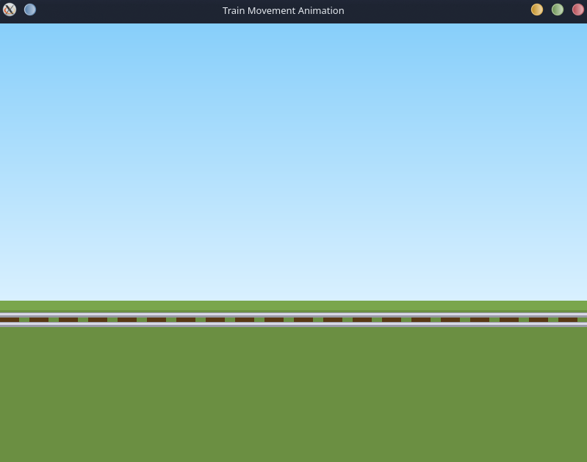
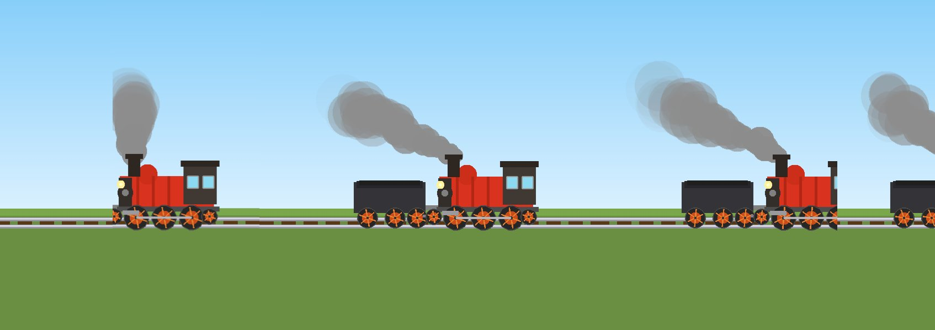
- Interaction: Pressing the 'u' key visibly accelerates both the train's forward movement and wheel rotation. Pressing the 'd' key dynamically decelerates the train until it comes to a complete halt, demonstrating real-time variable manipulation.

8. Conclusion
The Train Movement Animation project successfully proves that complex visual scenes and dynamic animations can be built from the ground up using minimal graphical primitives. By restricting the rendering to simple line segments, the project reinforced core computer graphics concepts such as algorithmic shape generation, trigonometric animation, particle physics, and state-driven event loops. The final product is a highly optimized, interactive, and visually engaging simulation that serves as a strong foundation for understanding lower-level computer graphics programming.

